The sun is the main source of space weather.
- Naturally occurring space radiation is always with us. It occurs when atoms, ions, or subatomic particles are accelerated to high velocity by processes such as solar particle events from the Sun. Disrupted propagation of radio signals emitted by satellites, disruptions in telecommunications, GPS position, aviation, and sometimes Earth’s ground electric power. Analyses of historical blackout events in the United States indicate that even short blackouts, which occur several times during a year in the United States, sum up to an annual economic loss between $104B and $164 B.

A.
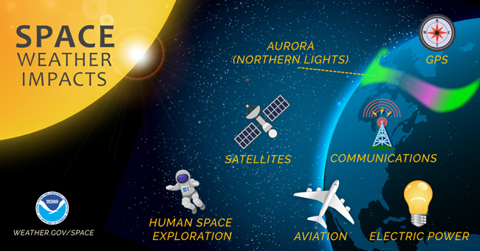

- Sunspots are dark regions on the surface of the sun resulting from the interaction of the sun’s surface plasma with its magnetic field.

B.
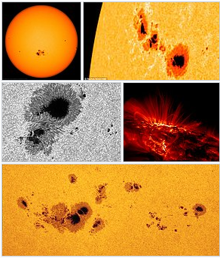

- The total number of sunspots has long been known to vary with an approximately 11-year repetition known as the solar cycle. The peak of sunspot activity is known as solar maximum and the lull is known as solar minimum.
C.
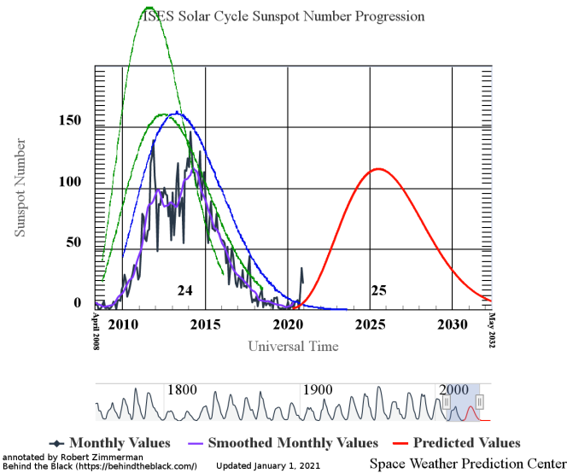

- Electrons, protons, and other particles are blasted into space with kinetic energy between 0.5 and 10 keV. as a result of powerful activities within the sun; they appear as a solar wind, propelled in all directions throughout space.
D.
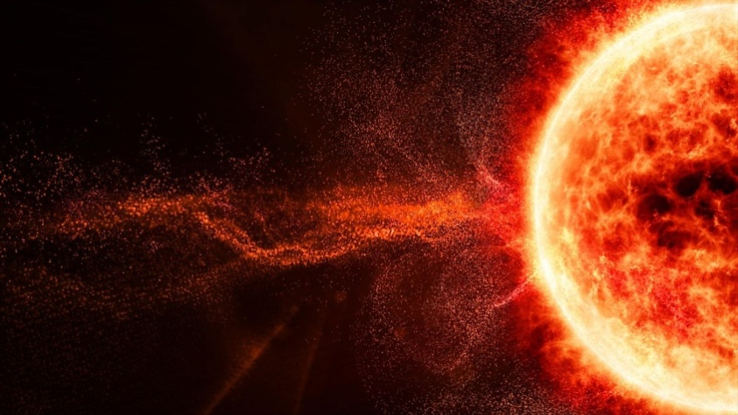

- On Earth their energy may be absorbed in the atmosphere near the North , South Poles and show as “auroras” (e.g., Northern Lights)
E.
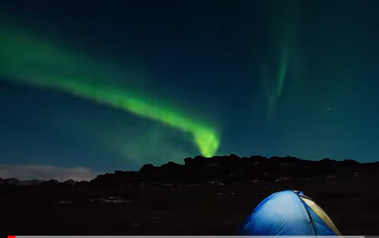

- When space weather hits and interacts with the Earth, geomagnetic storms occur. Geomagnetic storms caused by the Sun heat Earth's upper atmosphere, causing it to expand. The heated air rises and its density increases at the orbit of satellites. This overpowers the satellites’ engines causing them to fall back down to Earth and eventually burn up. This happened in 1979 with Skylab, in 1989 with U.S. Navy’s satellites, and again this past February with 40 0f 49 Space X satellites of Starlink Communications, costing about $50 M in losses.. Electrons penetrate shielding and accumulate within the spacecraft’s electrons to disrupt telecommunications or GPS operations.
F.
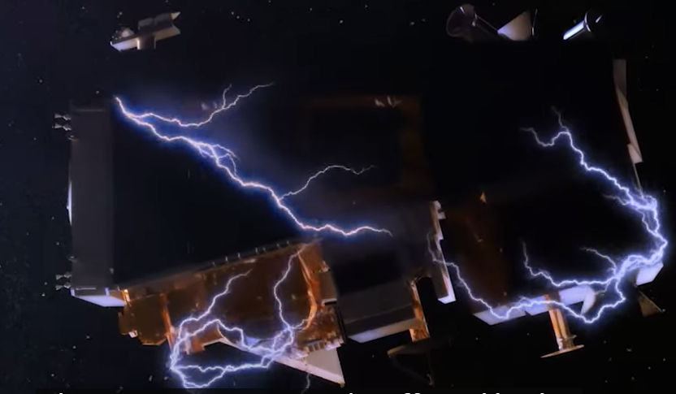

- Space Weather Prediction Center (NOAA) produces forecast expectations, and their respective measurements. Forecasting is the prediction of future events, based on analysis and modeling of the past and present conditions of the space weather environment.
G.
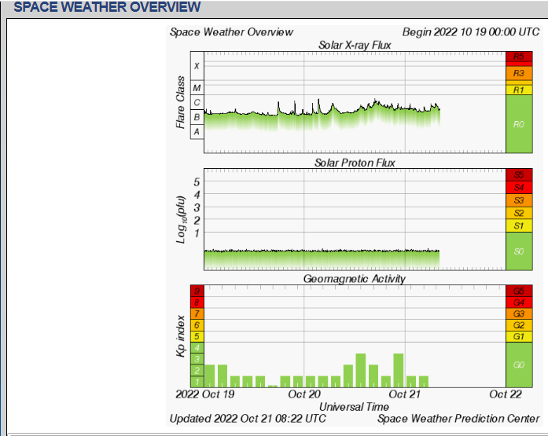
- As the incident cosmic ray particle collides with an atom or a molecule of the air, it produces lots of secondary particles. If it is a heavy ion, it will be broken into lighter nuclei, protons, or neutrons. This generates a cosmic ray cascade. The primary cosmic ray after reacting with air atoms and molecules must have a minimum energy of about 450 MeV to produce a significant number of secondaries that can reach sea level. One has to go to high mountains or use air planes, balloons or spacecraft to detect traces of primary cosmic rays of lower energies. The secondaries rarely reach the ground.
H.
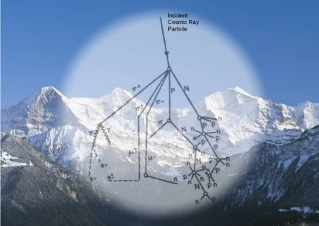

- Naturally occurring space radiation is always with us. It occurs when atoms, ions, or subatomic particles are accelerated to high velocity by processes such as solar particle events from the Sun. Failures occur from disrupted propagation of radio signals emitted by satellites, disruptions in telecommunications, GPS position, aviation, and sometimes Earth’s ground electric power. Analyses of historical blackout events in the United States indicate that even short blackouts, which occur several times during a year in, sum up to an annual economic loss between $104B and $164 B.
- Sunspots are dark regions on the surface of the sun resulting from the interaction of the sun’s surface plasma with its magnetic field.
- The total number of sunspots varies with an approximately 11-year repetition known as the solar cycle. The peak of sunspot activity is known as solar maximum and the lull is known as solar minimum.
- Electrons, protons, and other particles are blasted into space with kinetic energy between 0.5 and 10 keV as a result of powerful activities within the sun; they appear as a solar wind, propelled in all directions throughout space.
- On Earth their energy may be absorbed in the atmosphere near the North , South Poles and show as “auroras” (e.g., Northern Lights)
- When space weather hits and interacts with the Earth, geomagnetic storms occur. Geomagnetic storms caused by the Sun heating Earth's upper atmosphere, causing it to expand. The heated air rises and its density increases at the orbit of satellites. This overpowers the satellites’ engines causing them to fall back down to Earth and eventually burn up. This happened in 1979 with Skylab, in 1989 with U.S. Navy’s satellites, and again this past February with 40 0f 49 Space X satellites of Starlink Communications, costing about $50 M in losses. Electrons penetrate shielding and accumulate within the spacecraft’s electronics to disrupt telecommunications or GPS operations.
- Space Weather Prediction Center (NOAA) produces forecast expectations, and their respective measurements. Forecasting is the prediction of future events, based on analysis and modeling of the past and present conditions of the space weather environment.
- As the incident cosmic ray particle collides with air atoms or a molecules, it produces lots of secondary particles. If it is a heavy ion, it will be broken into lighter nuclei, protons, or neutrons. This generates a cosmic ray cascade. The primary cosmic ray after reacting with air atoms and molecules must have a minimum energy of about 450 MeV to produce a significant number of secondaries that can reach sea level. One has to go to high mountains or use air planes, balloons or spacecraft to detect traces of primary cosmic rays of lower energies. The secondaries rarely reach the ground.

Thank you.

